Indigenous Resistance
It is important to emphasise, as Behrendt does, that: “Although the colonists eventually prevailed, Aboriginal people around Australia resisted invasions onto the land, often tenaciously, with violent and tragic outcomes.”
Indigenous Australians didn’t passively accept the invasion of their land, resisting vigorously, and sometimes violently. It was not only their physical survival that was threatened; their cultural and spiritual survival was also at stake as sacred sites were desecrated and connection to Country disrupted. In response, they sometimes employed rebel tactics, including raiding farms, killing stock, burning buildings, and even killing settlers.
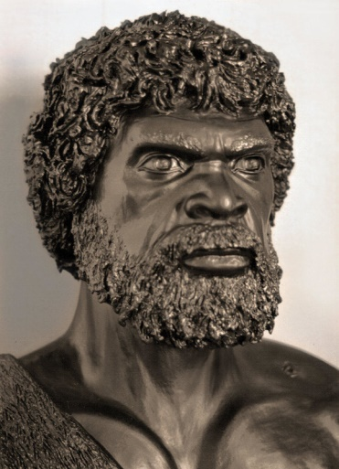
Pemulwuy was an Aboriginal warrior from the Bidjigal clan of the Dharug nation, and a leader of the resistance movement to the south and west of Sydney Cove. These conflicts became known as the Hawkesbury and Napean wars.
Pemulwuy and his son, Tedbury, led raids on cattle stations, killing livestock and burning crops and buildings. The purpose of these raids was sometimes to obtain food, however they were often in retaliation for violence committed against Indigenous people, particularly the women. In response, Governor King ordered the shooting on site of any Aboriginal person in the Paramatta region, and a reward was announced for Pemulwuy’s death or capture.
Pemulwuy survived two bullet wounds, but was eventually killed in June 1802 after being shot by two settlers. He was decapitated, and his head was shipped to England. His son, Tedbury, continued the resistance.
Windradyne was another significant leader of the Aboriginal resistance to white colonisation in the Bathurst region of New South Wales, where several violent clashes between Aboriginal people and white settlers prompted Governor Brisbane to place the district under martial law in August 1824. A reward of 500 acres was offered for Wyndradyne’s capture due to his involvement in incidents resulting in the death of several white settlers. However, Wyndradyne avoided capture, and was formally pardoned when he appeared at the Governor’s annual feast in an apparent move to negotiate. He died on the 21st March 1829 due to wounds suffered during a tribal fight.
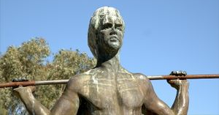
Yagan was a Noongar (or Nyoongar) warrior, and led the Aboriginal resistance in the Perth region, Western Australia, until he was killed by colonists in 1833. His head was severed, preserved, and sent to England. The conflict in the area continued after Yagan’s death; in 1834, Governor Stirling led an attack known as the Battle of Pinjarra. Unofficial reports hold that a whole clan of Aboriginal people was extinguished.
In 1997, Yagan’s skull was finally returned to the Noongar people.
In some areas, such as Arnhem land, Aboriginal resistance succeeded in stalling the spread of the frontier. However, as Behrendt notes, “in the end, the squatters had the law and the firepower on their side.” Indigenous people, their populations severely depleted by disease, dispossession and violence, drifted to the town fringes, cattle stations and Christian missions.
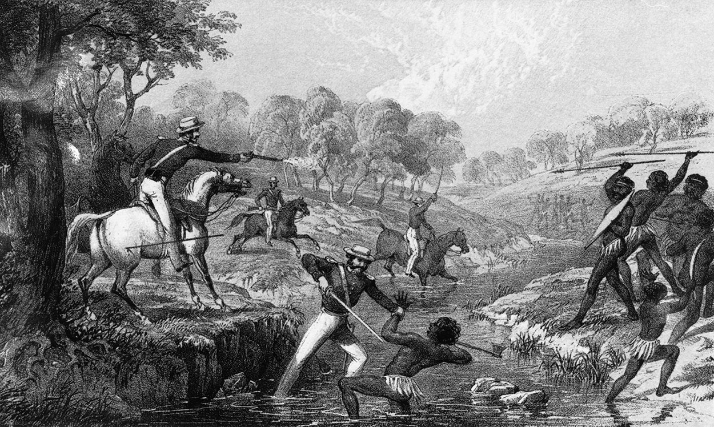
Despite this outcome, Indigenous people continue to demonstrate incredible resilience today as they fight for recognition of their dispossession and ongoing rights to land.

Figure 1: New South Wales Mounted Police engaging Indigenous Australians during the Waterloo Creek Massacre of 1838
Questions:

NOTE: Answer the following questions use the words in the question and the answers to form your
answer.
This will help you form topic sentences for paragraph responses and responding to short
answer questions in your exam.
- What word on line 6 means aggressively?
- According to lines 6 and 7, what aspects of aboriginal life did European settlement threaten?
- Who was leader of the resistance movement to the south and west of Sydney Cove?
- What was the reward offered for Wyndradyne’s capture?
- On line 29, what word means excused?
- On line 39, what was the attack led by Governor Stirling known as?
- There were many other battles and wars between the Aboriginal and European people. What were the names of these?
- On line 44, what does it state that the squatters have on their side?
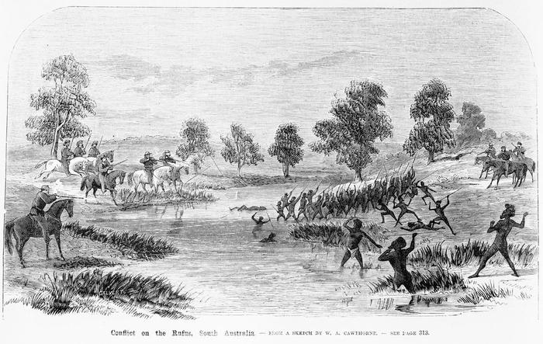
- On lines 45 and 46, what long term consequences did European settlement have on the aboriginal people?
Figure 2: Rufus River Massacre in Victoria.

