Queensland History Week Quiz | 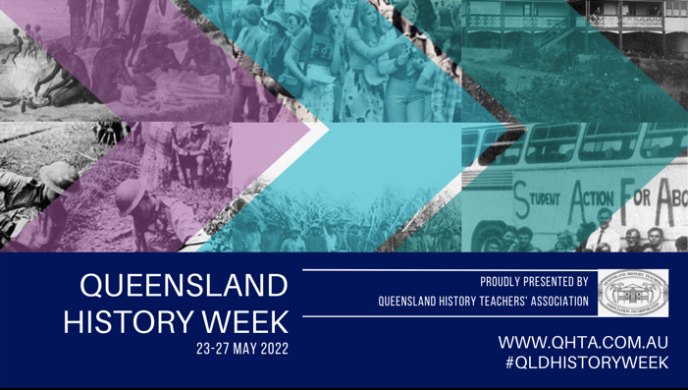

1. On what date did the anti-Chinese riots in Brisbane Chinatown occur?

- May 5, 1888
- April 5, 1898
- June 5, 1908
- July 5, 1918

2. Where did the Brisbane anti-Chinese riots start?

- Adelaide Street
- Albert Street
- Charlotte Street
- Queen Street

3. The hotel where two women protested for Women’s Liberation was,

- The Breakfast Creek Hotel
- The Caxton Hotel
- The Plough Inn
- The Regatta Hotel

4. Women could not enter or drink in a public bar in Queensland until,

- 1942
- 1958
- 1965
- 1974

5. According to The Dreaming, Carnarvon Gorge was created by,
- Adambara the spider
- Biladurug the platypus
- Mundagurra the rainbow serpent
- Tiddalick the frog

6. The rock art at Carnarvon Gorge dates back how many years?

- 19 500
- 45 000
- 3 500
- 60 000

7. Queensland coastal schools closed in WWII for almost

- 2 months
- 4 months
- 6 months
- 12 months

8. Air-raid shelters were built in Brisbane due to fears of an invasion by

- Germany
- Indonesia
- Japan
- Russia

9. The warrior who led the Jagera Nation against the pastoralists in 1843 was,

- Bennelong
- Jandamarra
- Multuggerah
- Pemulwuy

10. Prior to the Battle of One Tree Hill, First Nations warriors built,

- Barricades on the roads
- A fortress on the mountain
- A moat around the mountain
- Fences to keep the pastoralists out

