**Brisbane Girls Grammar School**

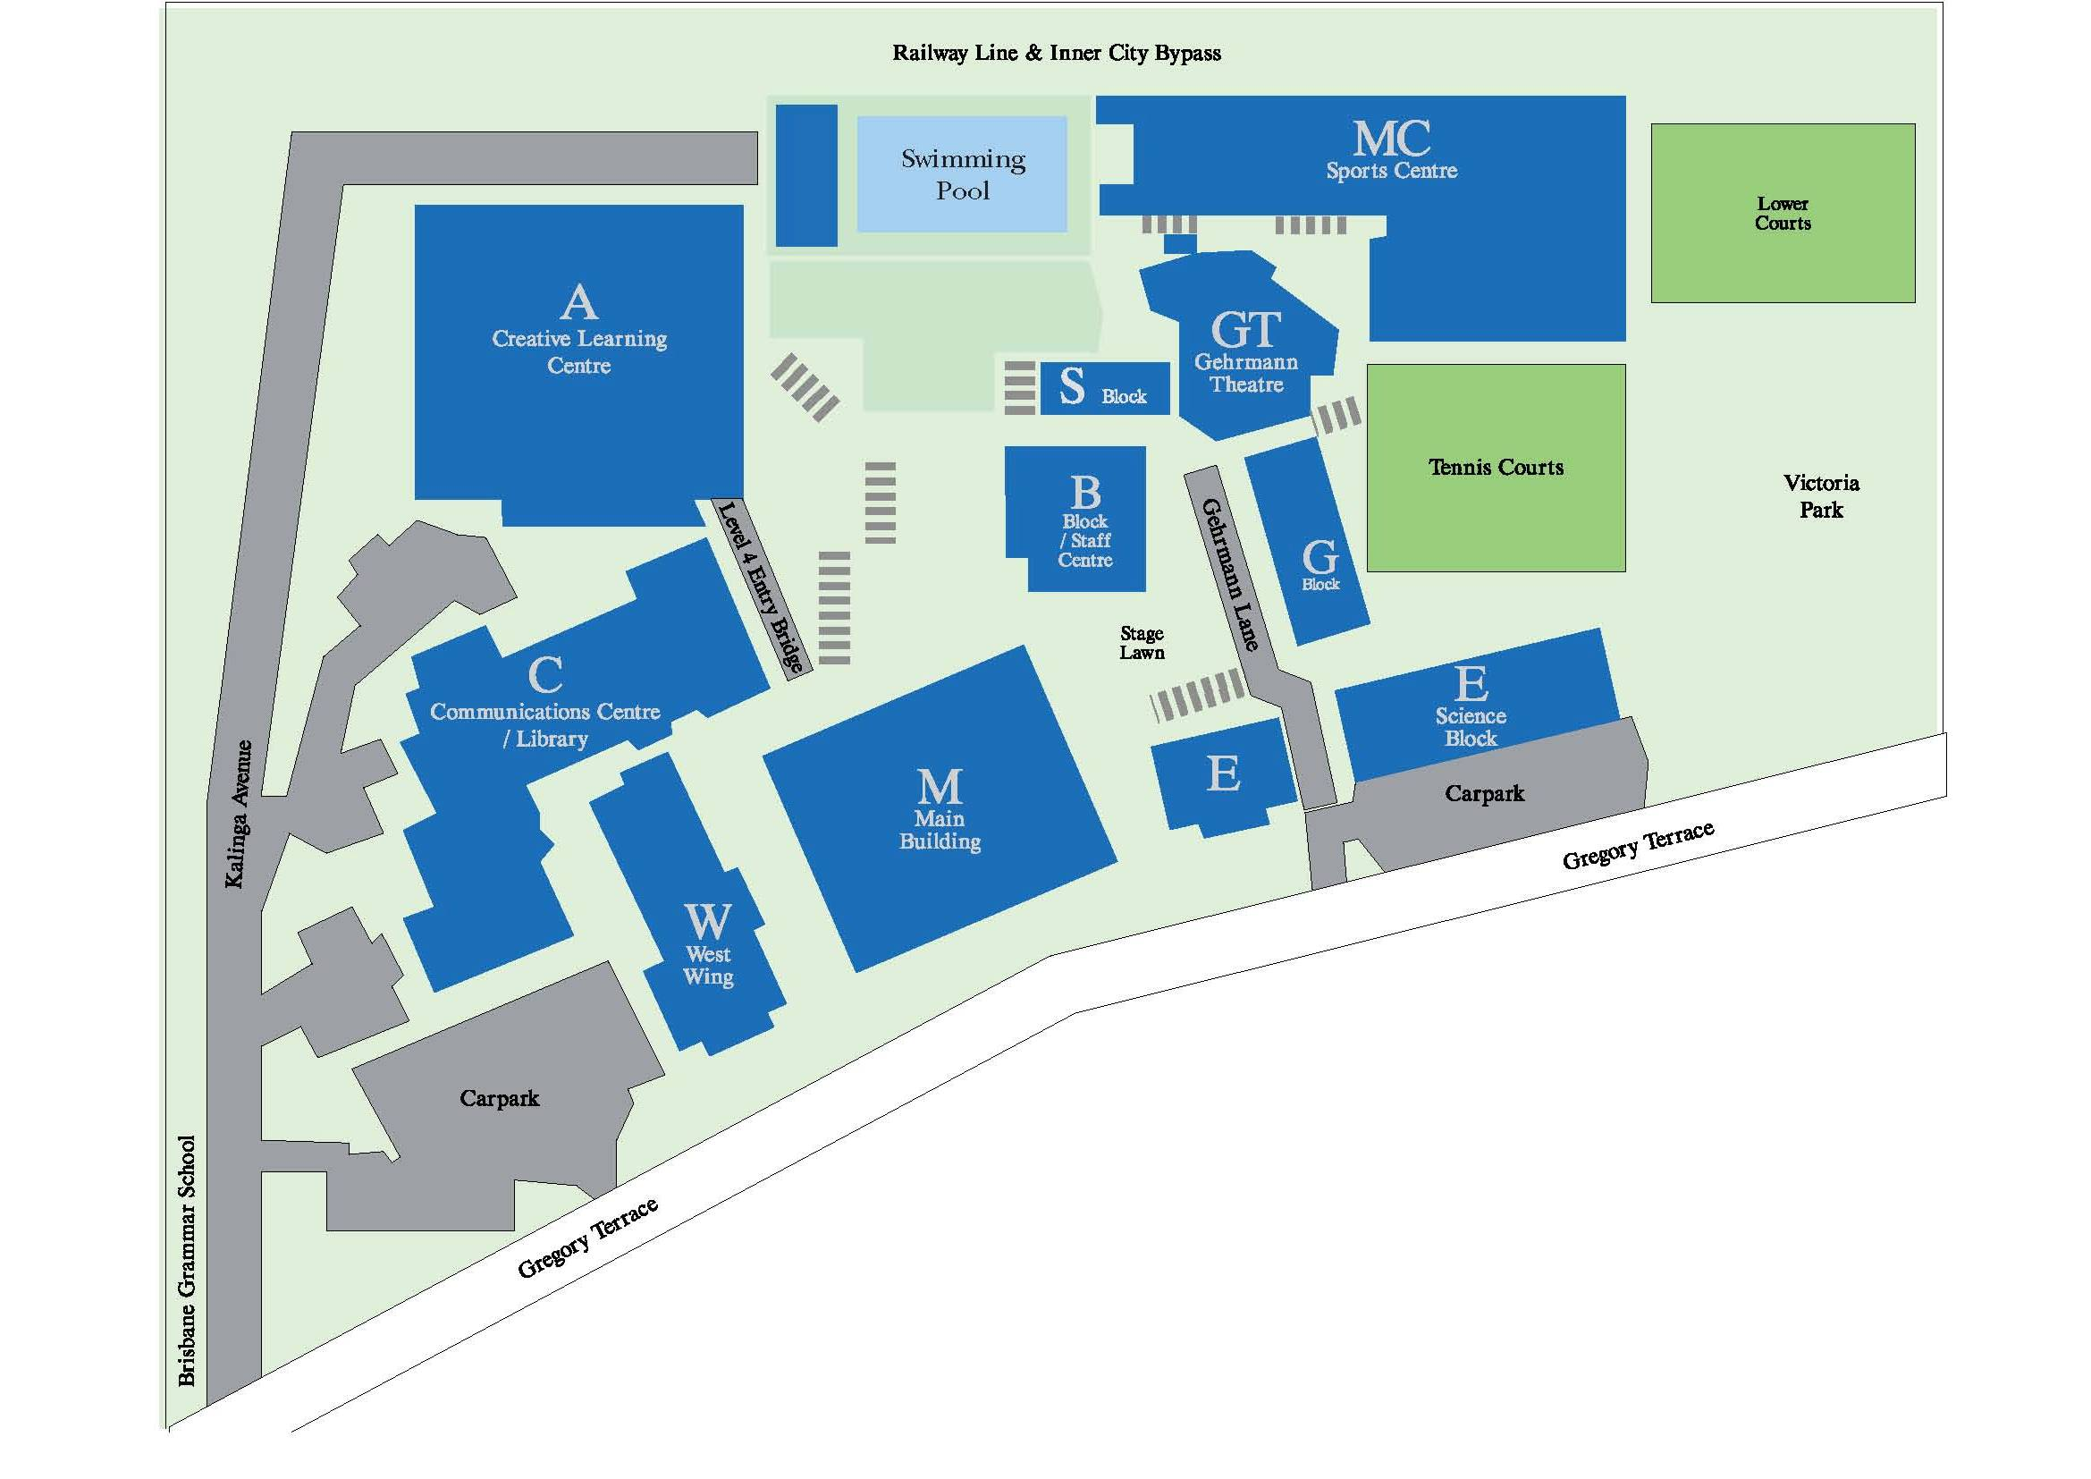

Trader and caterer parking

Registration

Gehrmann Theatre - Welcome and Keynote and some Workshops

b

Trade Displays

Refreshments on ground and workshops on levels 2 and 3

**Note on the map that most of the car parks are locked with a boom gate so please use the parks at the Boys' school described in the notes below.**

Brisbane Girls Grammar School -limited parking available so QHTA is grateful to the Brisbane Grammar School for providing parking space.

At the Brisbane Grammar School (boys' school to the left when looking at both schools), conference delegates can use

* the Rear Parking lot at the back of the school (see note below*). Boom-gate will be open from 7am.

If parking behind the Brisbane Grammar School but you have to enter the parking area from College Road <http://brisbanegrammar.com/images/stories/AboutGra/bgs_campus_map_2010.pdf> Note you cannot turn right across the traffic if you are already in College Road and coming from the city. You need to be heading south and turn left off College Road just after the Normanby intersection.