

Austro-Hungary



Austro-Hungary

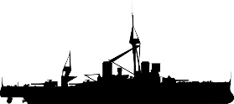

Austro-Hungary



France



France



France



Russia



Russia



Russia



Russia



England



England



England



Turkey



Turkey



Turkey



Italy



Italy



Italy



Germany



Germany



Germany



Germany