Diplomacy: Rules of the Game
- Each country’s forces begin in their country of origin. Each country will begin with a combination of armies and fleets. The number and starting positions are indicated on your country’s information cards.
- There are four turns in this game. Each turn is broken up into two stages: negotiations and movement.
- During negotiations, your country representatives will discuss the moves you will take in that turn, and secure any support your country needs from others in order to fulfil those objectives. Then, using a white-board marker, write these moves down on the back of your country card. Requirements for these objectives are outlined on your information card. You will be allowed five minutes for each negotiation period and to write your moves on the back of your country card. (note: all armies and fleets may move in a single turn).
- After negotiations are completed, each team will indicate their moves on the game board by telling the teacher their moves when their country is called upon. Each army or fleet can only occupy or move one sea or territory at a time, however all of your armies and fleets may move in a single turn. The game board will be projected on the classroom whiteboard and bluetac will be used to position your armies and fleets.
- Your country may need to attack an opposing country in order to secure an objective. In order to attack, simply write your attack down in the movement phase. However, you should only attack if you have more forces in surrounding territories, (this could include allied support). This support is why alliances are so important and where you will find the extra armies or fleets needed to secure your objectives.
- If countries try to occupy the same territory at the same time, neither force can successfully occupy the territory unless they have support from an adjacent (next to) fleet or army. If neither country has such support, they must both move back (bounce) to the territory they came from. Note: Fleets may occupy and support coastal territories and waterways only, no land-locked territories. Further, neither can armies support fleets into other sea territories – unless they have Jesus boots.
- The winning nations are those who fulfil all of their of their objectives – meaning, be a self-serving ally.
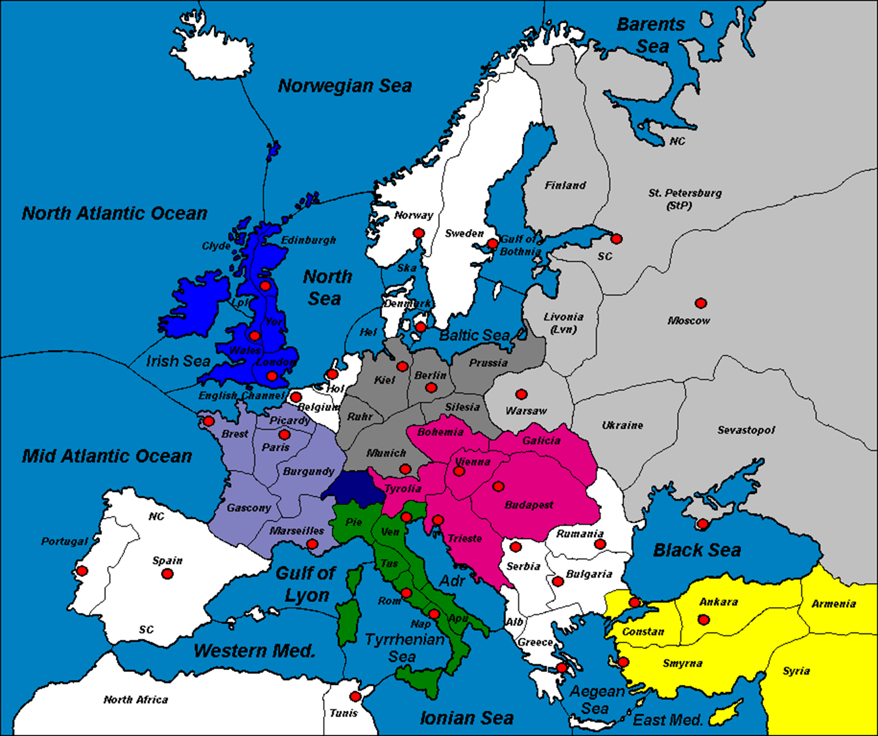
Legend:
Austria-Hungary
France
Italy
Germany
Great Britain
Russia
Turkey
Neutral

