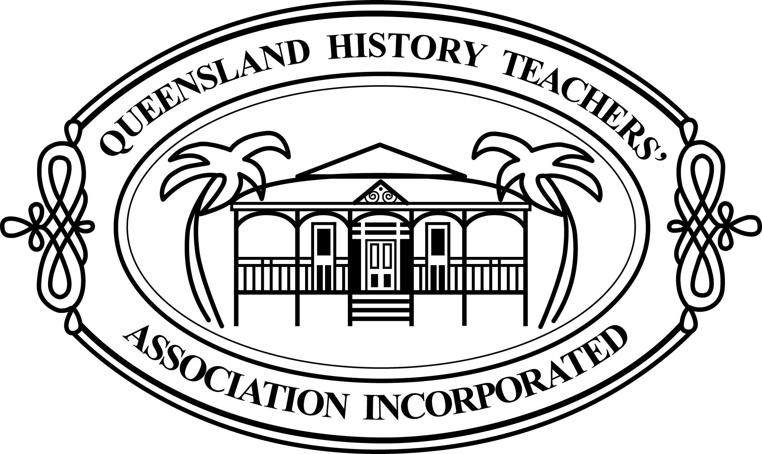

For your History students with an artistic streak!
QHTA is seeking some art work to use for the QHTA State Conference and possibly other publications throughout 2019, and we invite Queensland students to submit their work for consideration.
The theme of the 2019 Conference is What Matters? Some key words that could be given to students include – symbols, community, heritage, voices, exclusions, change, time, questions, as well as key images from History.

The winner will receive $100 in prize money and acknowledgement in any publications where the art is used.
Send the attached information and a jpg of the artwork to qhta@qhta.com.au by 1 March 2019.

Name of artist/student
Name of teacher
Teacher email address
School
School address

